**Name: Vivek Kumar**

**Company and Designation: DATA SCIENCE MANAGER - pwc**

**Topic: Computer Vision and Applications**

**Date:** 12th August, 2023

**Information:** Vivek Kumar stressed the pivotal role of computer vision, delving into Image Processing and its broad applications. Key topics included 3D recognition, object recognition through feature detection, motion estimation, and image classification using ML. Practical examples featured a Grab & Go shop and Health and Safety Monitoring, demonstrating real-world applications for retail and security.



**Name: Rahul Jain**

**Company and Designation: DATA ENGINEERING MANAGER - SNOWFLAKE**

**Topic: Demystify AI and its impact on the job market**.

**Date:** 2nd September, 2023

**Information**:The topic of the guest lecture was popular technical buzzwords, including Gen AI, ML, DL, and AI. The methods of Deep Learning (DL) and Machine Learning (ML) were described from input to output.Mr. Jain went into further detail regarding the importance of large and small language models, or LLMs. We talked about ChatGPT's development and unique features, like RHLF (Reinforcement from Human Feedback) and self-supervised learning.

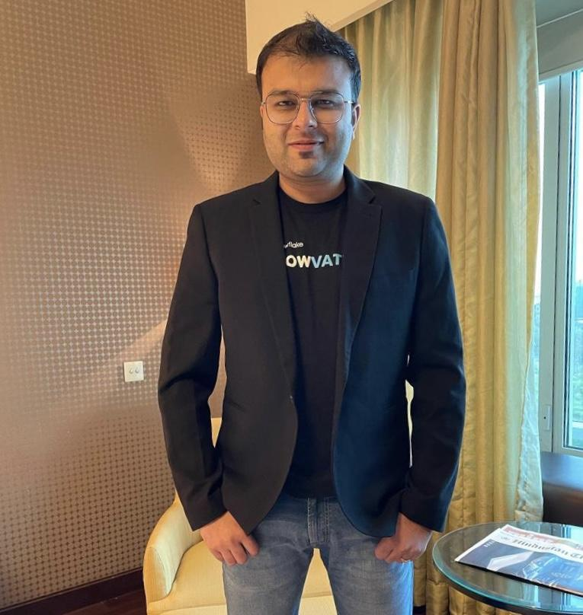

**Name: Sumit Mittal**

**Company and Designation: FOUNDER & CEO - TRENDYTECH**

**Topic: Importance of Big Data in Today's Market**

**Date:** 5th October, 2023

**Information:** Sumit Mittal explored Big Data's definition, emphasizing the need for new technology and scalable processing. Differentiate monolithic and distributed systems, delve into Hadoop, and grasp concepts like data distribution, MapReduce, and project workflows. Assess data pipelines, compare serverless and server-full architectures, analyze Apache Spark, discuss resilient distributed databases, and highlight their transformative role in Big Data.

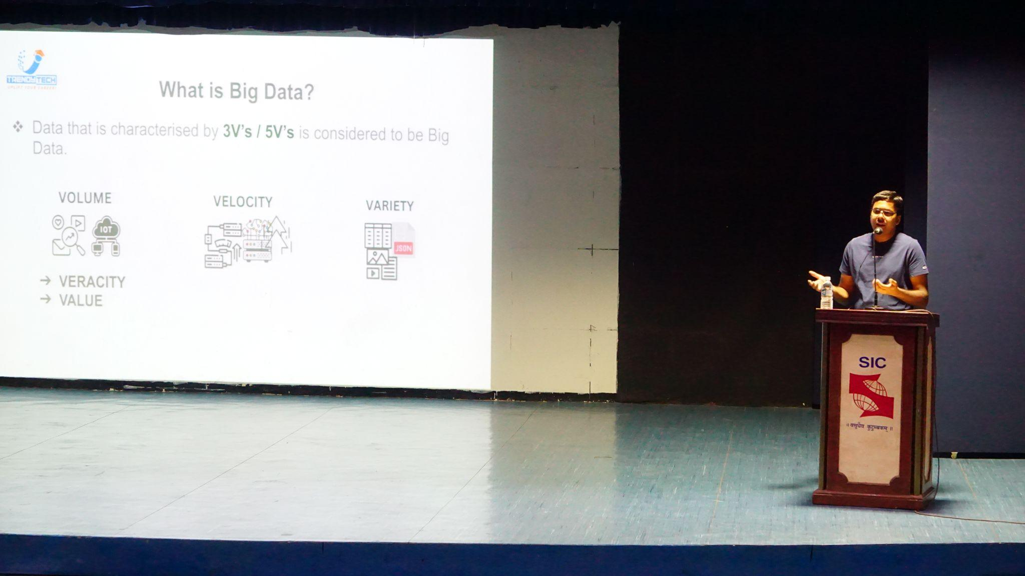

**Name: Markus Schaal**

**Company and Designation: DATA SCIENCE ADVISOR - WEBTREKK, GERMANY**

**Topic: Beyond AI & Data Science - Expectation of a New Data Scientist**

**Date:** 25th September, 2023

**Information**:Markus Schaal initiated a discussion on the untapped potential of AI, stressing the necessity of think-tank workshops. He addressed uncertainties in future scenarios, highlighting challenges at organizational and individual levels. Topics included preparing companies for digital transformation, current AI trends like predictive analysis, and the crucial role of data sharing and knowledge exchange.

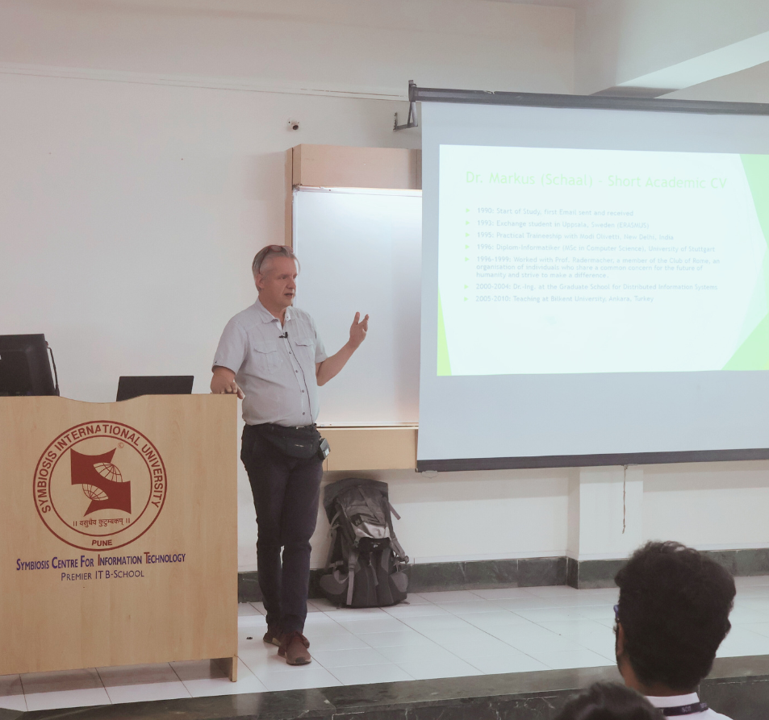

**Name: Mahesh Jadhav**

**Company and Designation: SENIOR MANAGER DATA & AI - ACCENTURE**

**Topic: AI/ML Applications in the Industry**

**Date:** 17th September, 2022

**Information:** The speaker started by emphasizing on the importance of data and data security, the use of cookies in browsers and how our data is captured by organizations to target their audience and potential customers. He further elaborated applications of machine learning, deep learning and AI. Some examples were how deep learning can be applied in sales and marketing using market basket analysis, predicting when a machine will break down, predicting best routes to save time etc. Towards the end, he had an interactive case study discussion with the students.

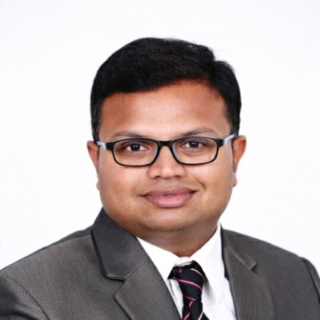

**Name: Mohit Tripathi**

**Company and Designation: DATA SCIENCE MANAGER - CONDE NAST TECHNOLOGY LAB**

**Topic: Sentiment Analysis Using NLP**

**Date:** 7th January, 2023

**Information:** The speaker stressed on the importance of big data, statistics and languages like SQL and PySpark. He also suggested courses with certifications for data scientists and data engineers like : A2-900, DP-100, DP-203, PL-300. He further elaborated the uses of analytics along with cloud computing. He then proceeded to show the students a working of Sentiment Analysis using NLP on Jupyter. Sentiment analysis (also known as opinion mining or emotion AI) is the use of natural language processing, text analysis and computational linguistics to systematically identify, extract, quantify, and study subjective information. Some of the topics mentioned were Stemming, tokenization, part-of-speech tagging and parsing.



**Name: Rajneet Kaur**

**Company and Designation: AVP DATA SCIENCE - eClerx**

**Topic: Data Storytelling**

**Date:** 9th October, 2022

**Information:** The speaker emphasized the importance of data storytelling in any organization. She highlighted that stories that incorporate data and analytics are more convincing and compelling. She also shared some very useful tips on how to think creatively and share a good story with data.

Some of the key highlights of the session shared by the speaker were:

• Importance of flow, message and making a story interesting

• Structuring a dashboard

• The components of data storytelling

• Visual Encoding

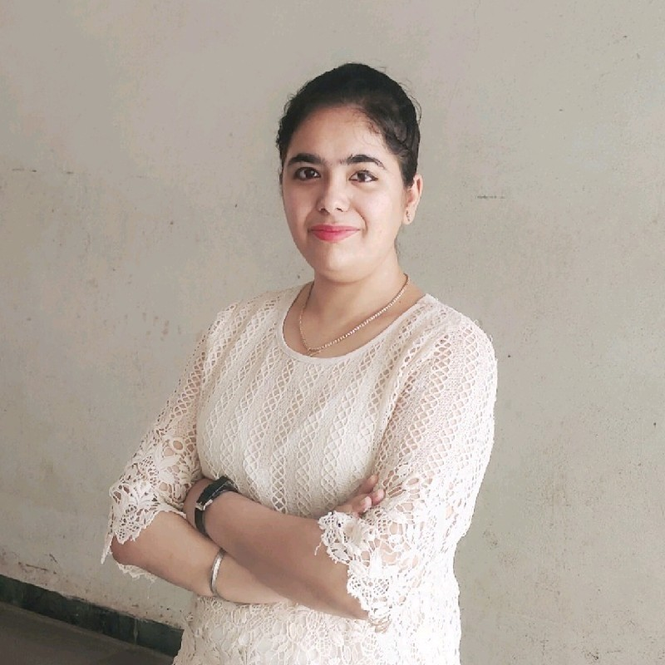

**Name: Tarun Singh Aswal**

**Company and Designation: CHIEF DATA OFFICER - IDBI Bank**

**Topic:** Data Analytics in BFSI

**Date:** 20th August, 2022

**Information:** The speaker illuminated the importance of Data Analytics and Science in the field of Banking Financial Services and Insurance. How it is being used in enriching the customer life cycle values in the Banking Industry. He then explained through his presentation about various

departments of Banks and how Information Technology is unitized across multiple divisions

within the bank. He went on to showcase few applications and examples of Analytics’ such as

ML, AI etc. in determining: Credit Risk Assessment, Insurance Validity, Interest Rate Adjustment based on real-time scenarios Customer Relationship Management Solutions.

